# CS 255 System Design Document Template

## UML Diagrams

### *UML Use Case Diagram*

### UML Activity Diagrams

***Manage Appointment Diagram (User Based)***

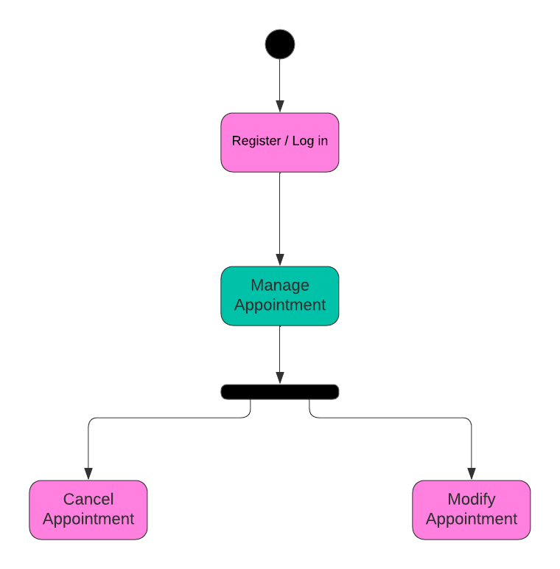

***Manage Accounts Diagram (IT Based)***

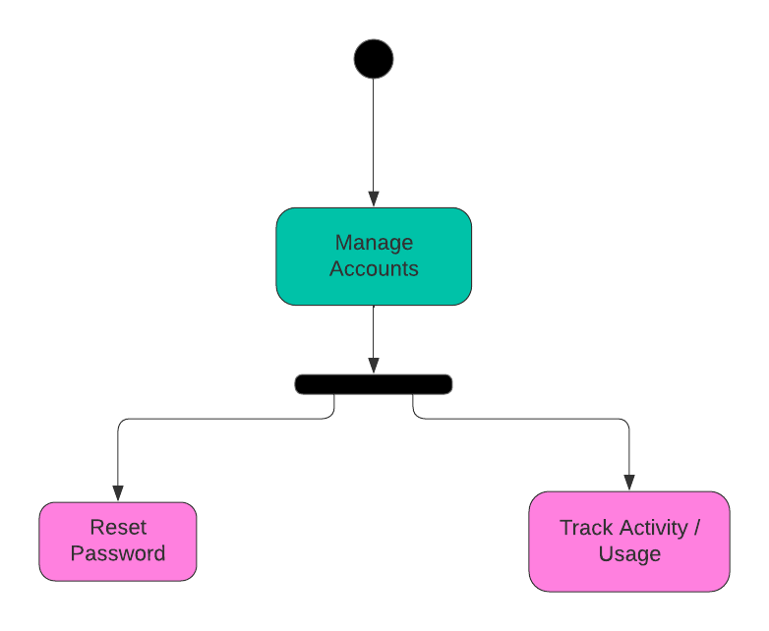

### UML Sequence Diagram

***Manage Appointment Sequence Diagram***

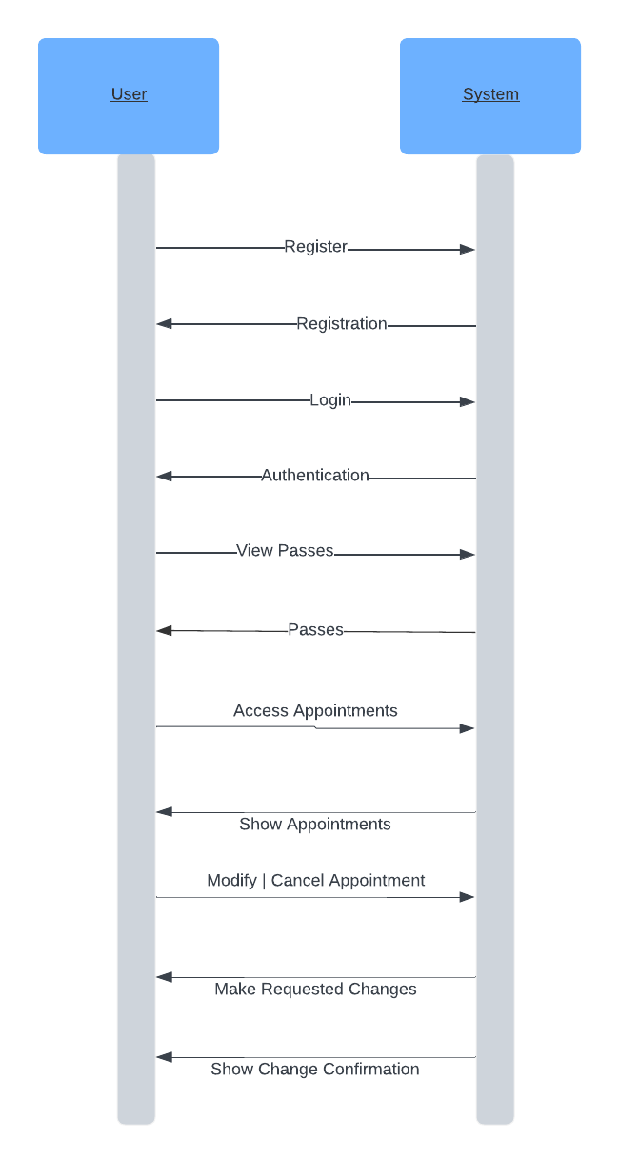

### UML Class Diagram

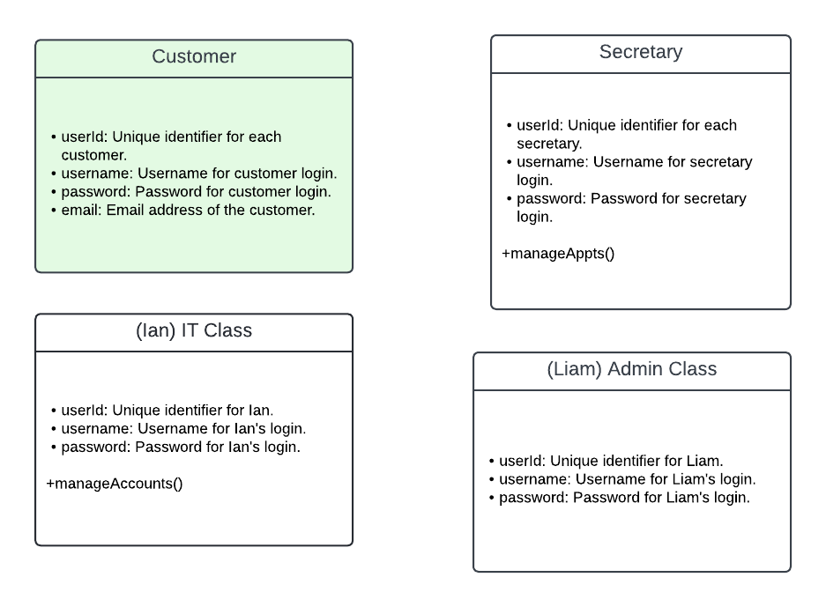

1. ***System Infrastructure*:**
   * Hardware and Connectivity: The system will need basic computers with internet access for users to log in and use it.
   * Device Compatibility: It should work on different devices like laptops, tablets, and smartphones, making it easy for users to access anytime, anywhere.
   * Data Security Measures: Will make sure that user data is safe by using strong security features like encryption and secure logins.
2. ***Development and Maintenance Practices*:**
   * Software Toolchain: Will use standard software tools for building, testing, and maintaining the system.
   * Quality Assurance: Will test the system thoroughly to find and fix any problems before it goes live, making sure it works well for users.
3. ***Cloud-Based Infrastructure:***
   * Cloud Hosting Solution: Will use cloud services to host the system, which allows it to grow easily as more people use it.
   * Scalability and Resilience: The system will be designed to handle lots of users at once without slowing down, and it'll stay online even if there are technical issues.
   * Data Protection Measures: will keep user data safe in the cloud by using strong security measures like encryption and access controls.
4. ***User Support and Training:***
   * Support Services: Users can get help quickly through email, chat, or a helpdesk if they have any questions or problems.
   * Training Resources: We'll create guides and tutorials to help users learn how to use the system effectively.